Figure 1. Tripartite graph, using only one-way matching. No weights

Figure 3. Oneway match, weights attached

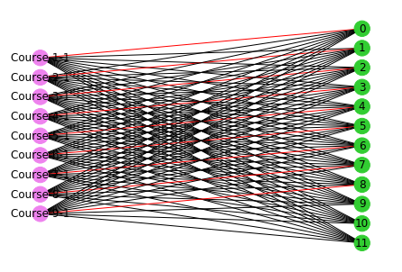

Using networkX and preflibs AGU University of Science and Technology course preferences dataset, we conducted some matching tests.

We limited the take into 11 first students. Each student had ranked their preferences for which course they would like to take from years 2003 and 2004. We took students from both datasets, and labelled set 1 students 1-11 and set 2 students 1-11 and constructed a multipartite graph according to that.

Each ranking was assigned an edge weight in the multipartite graph, (1/len(val))\* (len(val)-index2). So accordingly, this normalizes the weight based on the rank given.

As network did not support multigraph matching, we implemented it.

The code for this was rather unoptimized, as there was no reason to specify further in this case.